Scientific Research Permit Application Work Plan
Primary Research/Contact Person
Kayla I Perry, PhD
Assistant Professor of Forest Entomology
Ohio State University
Department of Entomology
1680 Madison Ave., Wooster, Ohio 44691
Office: 330-263-8002
Cell: 440-813-0217
Email: perry.1864@osu.edu

Organization/Institution Information
The Ohio State University
Department of Entomology
1680 Madison Ave., Wooster, Ohio 44691

Research Summary
Title: Characterizing the legacy of emerald ash borer on ash populations near the epicenter of invasion in North America

Research Objectives: This project aims to characterize post-outbreak forests by determining the extent and severity of ash loss caused by emerald ash borer (EAB; Agrilus planipennis Fairmaire) with a focus on the health and regeneration of the orphaned cohort of ash. Objectives are to determine the status of the orphaned cohort of ash in the forest understory, to identify potentially resistant ash genotypes in the forest overstory, to monitor populations of EAB, and to survey the community of established native and introduced natural enemies of EAB. To accomplish these objectives, we will resurvey sites previously established near the epicenter of EAB invasion in southeastern Michigan. Understanding the potential for ash survival and regeneration in post-outbreak forests will inform ash conservation and help refine integrated pest management programs as EAB continues to spread across North America.

Project Description: Forests in southeastern Michigan near the epicenter of invasion have experienced the longest duration of EAB infestation in North America, with ash mortality exceeding 99% by 2009. Although most mature ash have died within the region, an abundant orphaned cohort of established ash seedlings and saplings have been documented in the understory, but no new germination after 2008. As immature ash trees grow and become susceptible to EAB, the survival of the orphaned cohort of ash in the understory is key to the persistence of ash in natural forests.

Long-term persistence of ash hinges on the dynamic interactions among the orphaned cohort of ash, lingering ash, low-density EAB populations, and efficacy of native and introduced natural enemies. However, evidence suggests that the cumulative effects of native and introduced parasitoids have not been capable of suppressing high-density outbreak populations of EAB or slowing the rate of ash mortality. Parasitoids may be most effective in post-outbreak forests once EAB populations have peaked and subsequently declined. Whether natural enemies can facilitate the long-term survival and regeneration of ash populations in post-outbreak forests remains a significant knowledge gap, but critical for the conservation of the genus Fraxinus in North America.

This study is resurveying 129 vegetation plots previously established in mixed hardwood stands in five Michigan State Recreation Areas (Brighton, Highland, Island Lake, Pontiac Lake, and Proud Lake) and three Huron-Clinton Metroparks (Hudson Mills, Indian Springs, and Kensington) in the upper Huron River Watershed. Black (F. nigra), green (F. pennsylvanica), and white (F. americana) ash were once abundant in the overstory before the establishment of EAB. Ninety-three vegetation plots were established in 2004-2005, twenty-one plots were added in 2006, and fifteen plots in 2008. Vegetation plots are spatially arranged in groups of three to provide replication within stands, resulting in 43 forest transects. Plots are 18 m in radius (0.1 ha) around a center tree and contain a multiscale sampling scheme. Within each 18 m plot, there is a central 8 m radius (0.02 ha) subplot and four 4 m² microplots centered at 8 m in each cardinal direction. Transects have been GPS mapped and thoroughly characterized for plant species composition and EAB impacts on ash regeneration, successional trajectories, and exotic understory plants.
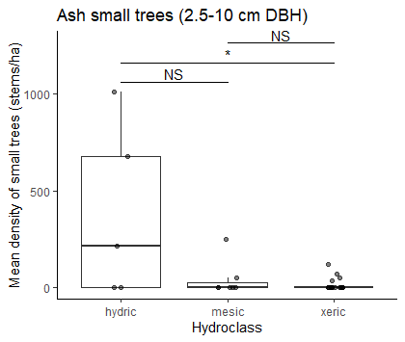
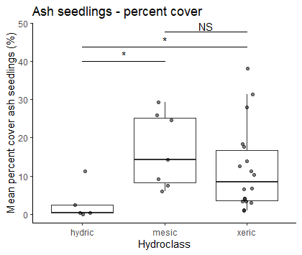
B
A
Preliminary Findings in 2024:

We have relocated and surveyed ash regeneration in 97 out of 111 plots and intend to complete the dataset in summer 2025.

We found an orphaned cohort of ash in transects of all soil moisture classes (hydric, mesic, and xeric), but the size of ash regeneration varied by soil moisture class. In mesic riparian and dry xeric transects, ash regeneration remained at the seedling (0-137 cm height) or sapling (< 2.5 cm diameter at breast height, DBH) level. Conversely, wetter hydric transects had sizeable counts of small ash trees (2.5-10 cm DBH), but low numbers of ash seedlings (Fig. 1).
Figure 1. Occurrence of ash in 30 transects varying in soil moisture class (x-axis). A) Average % cover of ash seedlings (0-137 cm tall). B) Average stem density of small ash trees (2.5-10 cm DBH)

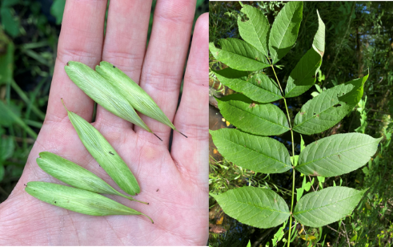
Newly germinated seedlings (those with cotyledons) were not found in 2024 despite surveying 388 microplots. However, 2,826 established seedlings under breast height (137 cm) were counted in 30 completed transects, making an average of 2.0 established seedlings / m². A total of 897 ash saplings have been tallied in 30 transects, for an average of 500 saplings / ha. In the 97 plots so far completed, 313 small ash trees have been counted. Of these, 177 are black ash. Only 9 ash trees above 10 cm DBH were found in surveyed plots.
Figure 2. Black ash samaras and leaf.

Although new ash seedlings were not found, we did observe black ash trees producing seeds, including black ash trees at Proud Lake Recreation Area and Indian Springs Metropark (Fig. 2).

For each of the ash trees ≥ 2.5 cm in our transects, we recorded signs and symptoms of EAB attack, such as canopy leaf defoliation and the production of epicormic sprouts from the trunk due to vascular system stress. Our models show that the presence of EAB symptoms and canopy decline generally increases from 2.5 cm DBH to around 9 cm DBH (Fig. 3A). However, of the small number of trees above 10 cm DBH, a higher proportion appear to be healthy (Fig. 3A). Although many black ash trees are declining, there are some in the 7.5 -12.5 cm range which remain healthy (Fig. 3B).

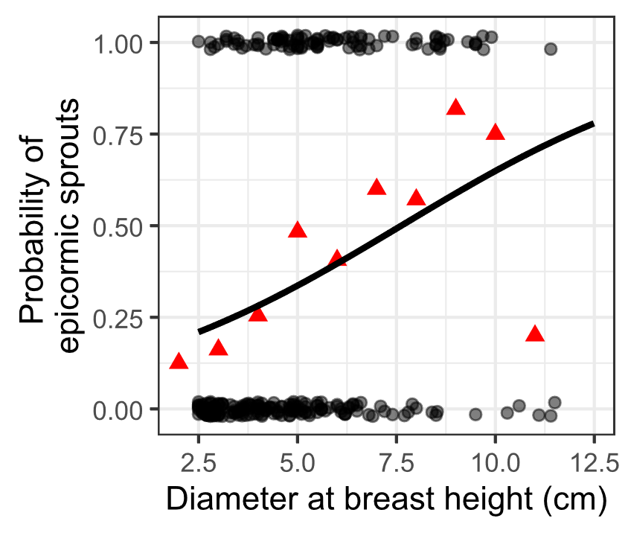
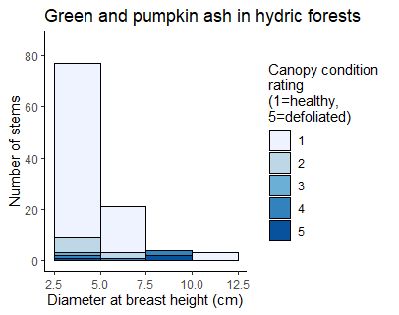
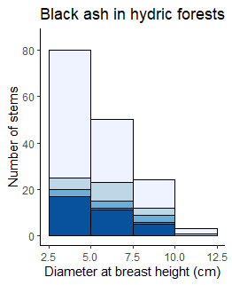
Figure 3. Health of ash trees in transects in the Upper Huron River Watershed. A) The y-axis represents the presence (1) or absence (0) of epicormic sprouts on the trunk, a symptom of EAB. The black line is the fit for a binomial generalized linear mixed-effects model with DBH as fixed effect and plot as random effect. Red triangles indicate means of groups binned by DBH. The sample size is 272 trees located in 6 hydric and 1 mesic transect. B) Histogram of black ash (Fraxinus nigra). Shading represents the proportion of each size class with each canopy condition rating, with darker shades indicating more canopy decline. C) Same graph for green ash (Fraxinus pennsylvanica) and possibly pumpkin ash (Fraxinus profunda), which were not separated during species identifications.
A
C
B

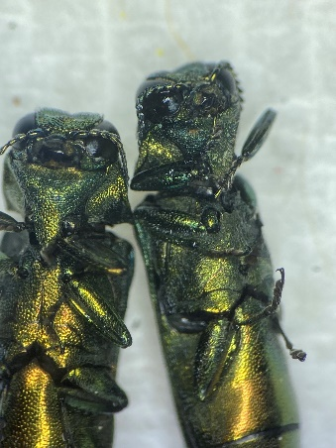
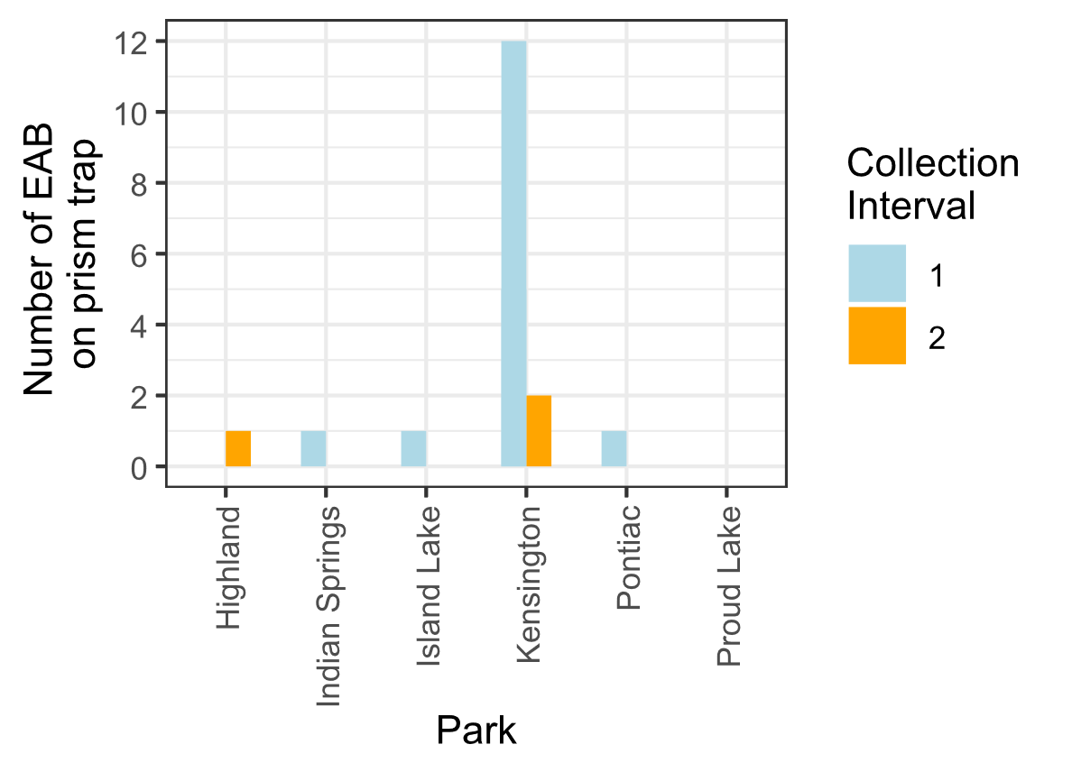
Emerald ash borer populations were assessed at six parks using two purple prism sticky traps per park. Manuka oil was used as a volatile lure, and traps were hung on or adjacent to the largest ash trees that could be found at each park during preliminary park visits. Traps at Highland Recreation Area were hung above ash seedlings 5 ft from ground level, while traps at other parks were hung between 7-30 ft above the ground. Traps were installed between May 29th and June 5th, 2024, were checked after one month and the lures replaced, and finally removed during July 23-25. Buprestid beetles were removed and brought to the lab for identification. We collected EAB at 5 of the 6 parks where we sampled (Fig. 4). Kensington Metropark had the highest numbers of EAB on prism traps, but the total number of EAB caught in all parks was relatively low, with only 18 EAB caught in total.
Figure 4. Emerald ash borer and graph of prism trap collections of EAB in summer 2024. Collection interval 1 and 2 are for June and July, 2024, respectively.

Taken together, our preliminary results suggest that, within our study transects, ash in hydric forests have come closer to regaining their position as mature trees, while ash in mesic and xeric forests remain at the seedling or sapling level. Although EAB is present at all parks based on the observation of signs and symptoms of EAB, populations appear to be low, at least based on the sampling techniques we employed.

Proposed research in 2025:
Our first goal is to complete the survey of the occurrence and health of the orphaned cohort of ash. We have 14 plots left to complete, which are located at Hudson Mills Metropark (5 plots), Indian Springs Metropark (6 plots), and Island Lake Recreation Area (3 plots). These plots will be relocated and the 12-inch PVCs marking microplots will be replaced if missing. Ash seedlings, saplings and small trees, and trees will be surveyed in microplots, 8 m subplots, and 18 m main plots, respectively. This will complete the dataset that was started in 2024.

Fueled by our observations that black ash is recovering in some hydric transects, we plan to further explore factors that influence tree regeneration in hydric transects. Our objective is to determine the growth rates of black ash trees in relation to co-occurring tree species. We hypothesize that within hydric plots, the death of overstory ash between 2004-2009 likely caused increases in water table elevation, and this would favor flood-tolerant tree species, while damaging or killing trees that are flood-intolerant. Given this hypothesis, we predict that tree species with a wetland indicator status of Obligate Wetland or Facultative Wetland, such as black ash, have grown faster in hydric plots than species with Facultative or Facultative Upland designation.

This objective will be conducted within 30 hydric plots located at Kensington Metropark, Indian Springs Metropark, Proud Lake Recreation Area, and Island Lake Recreation Area. The tree species in these plots (based on 2024 observations), grouped by Wetland indicator status, are listed in Table 1.
Table 1. Common tree species found in hydric plots in the Huron River Watershed, along with their wetland indicator status. Tree species are based on preliminary surveys, and Wetland indicator status was noted for the Midwest region from the USDA PLANTS Database.
Wetland indicator status | Tree species found in hydric plots in the Huron River Watershed
Obligate wetland | Pumpkin ash (Fraxinus profunda), Poison sumac (Toxicodendron vernix)
Facultative wetland | Black ash (Fraxinus nigra), Green ash (Fraxinus pennsylvanica), Silver maple (Acer saccharinum), Tamarack (Larix laricina), American elm (Ulmus americana), Swamp white oak (Quercus bicolor), Pin oak (Quercus palustris)
Facultative | Eastern cottonwood (Populus deltoides), Yellow birch (Betula alleghaniensis), American hornbeam (Carpinus caroliniana), Red maple (Acer rubrum)
Facultative upland | American basswood (Tilia americana), Bitternut hickory (Carya cordiformis), American beech (Fagus grandifolia), Black cherry (Prunus serotina)

Within the 18-meter radius main plot, we will record the diameter and species of all canopy trees (≥ 12.5 cm diameter). Diameter at breast height (DBH) will be measured at a height of 1.37 m using a DBH tape measure. We will classify each tree as living or dead and record the compass direction and distance to the center tree.

Data analysis
We will directly compare the tree diameters recorded in 2004-2005 with those found in 2025 by matching the compass directions and distances to the center tree. Then we will calculate the relative growth rate (RGR) using the formula: RGR={ln(BA_{t})-ln(BA₀)}/t. To investigate whether tree species differ in RGR in hydric plots, we will use a linear mixed effects model implemented in R using the “lme4” package. We will investigate whether flood-tolerant species (those listed as Obligate wetland or Facultative wetland) have had higher growth rates than those species which are intolerant of long-term flooding (Facultative or Facultative upland).

Field personnel for the 2025 field season will include Dr. Kayla I Perry, Assistant Professor; Diane M. Hartzler, Senior Research Technician; Aaron Tayal, MS Graduate Student, and ______________________, undergraduate research assistant.

Specific Park Location
Vegetation plots previously established during the early stages of ash mortality are in the Huron-Clinton Metroparks Hudson Mills, Indian Springs, and Kensington Metroparks (see attached plot list and maps).

Timing
This project will occur from June to August 2025. To complete this work, we anticipate trips will occur every week, each lasting 4 days.

Equipment
Equipment left on site will aid in future data collection. Round aluminum tree tags will be placed at the base of the center trees. If the center tree has been lost, a 12-inch PVC will be used to mark the plot location. The center tree or PVC will additionally be marked with striped, blue/black flagging. Four 12-inch PVC pipes will be installed to mark the center of the 4 m² microplots in each cardinal direction. Insect traps will be left on site to collect emerald ash borer adults and parasitoid wasps present in these forests.

Site Impact
No expected impact to forested park land.

Collections
This research will involve collections of insect specimens that will be brough back to the Perry laboratory at the Ohio State University Wooster campus for identification. We will collect emerald ash borer adults using purple prism traps and green multifunnel traps at each park. We also will collect parasitoid wasps using yellow pan traps in a subset of sites.

Research Products
We have presented results from this study at two conferences to date (the Ohio Valley Entomological Association Conference and the Ohio Wildlife Management Conference) and are currently preparing results to share at the national USDA Interagency Research Forum on Invasive Species. We will complete the survey of ash tree occurrence and health in 2025 in order to create a snapshot of ash regeneration. This will improve our understanding of long-term forest recovery after the spread of invasive tree pests. We will continue to communicate our results to scientists and the public through outreach events, such as Insect Night Walk organized by the graduate students at Ohio State University.

Anticipated Products
Findings from this research will inform integrated pest management programs as the persistence of ash may suggest improved efficacy of biological control agents for regulating low density EAB populations. Identification of healthy lingering ash will contribute to ongoing ash resistance breeding programs. This project will provide field and laboratory training to graduate and undergraduate students, contributing to an MS thesis. Findings will be disseminated to the public through extension and outreach publications and presentations, and to the scientific community through peer-reviewed publications and conference presentations (Entomological Society of America and USDA Interagency Research Forum on Invasive Species). Data from this project will build on an existing database investigating the ecological impacts of EAB on forest ecosystems. Long-term datasets such as this are invaluable for understanding the impacts of invasive species. Data archived as a continuation of this long-term study can be revisited again in the future. Data and analysis code will be made publicly accessible via GitHub, which will be archived via Zenodo for a citable DOI.

